|

**SOFTWARE REQUIREMENT SPECIFICATION**

**RATE PAYMENT SERVICE**

**FOR**

**KANDY MUNICIPAL COUNCIL**

Table of Contents

**1.** **INTRODUCTION** 4

**1.1.** **Purpose** 4

**1.2.** **Intendant audience and users** 4

**1.3.** **Document over view** 4

**2.** **OVERALL DESCRIPTION** 4

**2.1.** **Product perspective** 4

**2.2.** **Operating environment** 5

**3.** **SYSTEM FEATURES** 6

**3.1.** **User Login** 6

**3.1.1.** **Flow chart** 6

**3.1.2.** **Description** 6

**3.1.3.** **Stimulus/ Responses** 6

**3.1.4.** **Functional Requirement** 7

**3.2.** **Add new property** 7

**3.2.1.** **Flow chart** 7

**3.2.2.** **Description** 7

**3.2.3.** **Stimulus/ Responses** 8

**3.2.4.** **Functional Requirement** 9

**3.3.** **View added property details list.** 10

**3.3.1.** **Flow chart** 10

**3.3.2.** **Description** 10

**3.3.3.** **Functional Requirement** 10

**3.4.** **View details of a property.** 11

**3.4.1.** **Flow chart** 11

**3.4.2.** **Description** 11

**3.4.3.** **Stimulus/ Responses** 12

**3.4.4.** **Functional Requirement** 12

**3.5.** **View property due amount details and payment.** 12

**3.5.1.** **Flow chart** 12

**3.5.2.** **Description** 12

**3.5.3.** **Stimulus/ Responses** 13

**3.5.4.** **Functional Requirements** 14

**3.6.** **Remove property details** 14

**3.6.1.** **Flow chart** 14

**3.6.2.** **Description** 15

**3.6.3.** **Stimulus/ Responses** 15

**3.6.4.** **Functional requirement** 15

**4.** **EXTERNAL INTERFACE REQUIREMENT** 15

**4.1.** **User Interfaces** 15

**4.2.** **Hardware Interfaces** 15

**4.3.** **Software Interfaces** 15

**5.** **NON-FUNCTIONAL REQUIREMENT** 16

**5.1.** **Software Quality Attributes** 16

**5.2.** **Performance Requirements** 16

**5.3.** **Safety Requirements** 16

**5.4.** **Security Requirements** 16

Appendix A 17

Use case diagram 17

*Figure 1-Login ………………………………………………………………………………………………………………… 6*

*Figure 2- Add new property ………………………………………………………………………………………….. 7*

*Figure 3-View added property details list …………………………………………………………………… 10*

*Figure 4-View details of property ................................................................................... 11*

*Figure 6-View property due amount and do payment ……………………………………………. 12*

*Figure 7-Remove property ………………………………………………………………………………………….. 14*

**Document Acceptance**

|  |  |
| --- | --- |
| Deliverable | Software Requirement Specification- Rate Management Service |
| Deliverable Date | 29/11/2022 |
| Client | Kandy Municipal Council |

|  |  |  |
| --- | --- | --- |
| Date | Author | Reviewer |
| 29/11/2022 | M.M.H.R.Kumari |  |
|  |  |  |

Document Amendment Register

# **INTRODUCTION**

## **Purpose**

This document states the Software Requirement Specification for implementing the web based Rate payment service portal for the part of Kandy Municipal council. The proposed system will facilitate the introduction of a new solution that could enhance and improve the service standards offered to the customer. The Purpose of this document is to provide guidelines for the development of **the Rate payment service of the Kandy Municipal council.**

## **Intendant audience and users**

This project is a prototype for the Rate payment service online platform that user can register online. This project need to save customer-sensitive information and this has been implemented under the guidance of council members. This service is useful for the All council members and as well as to their customers.

## **Document over view**

This software requirement specification document specially designed for the on the Rate payment service of the Kandy Municipal council and Focusing on the functionality and interfacing of the solution.

* Detailed functionality description for each module.
* Technical diagrams
* Stimulus and system responses

# **OVERALL DESCRIPTION**

## **Product perspective**

* **User login**

A login page is a web page or entry page to a website that requires user identification and authentication, regularly performed by entering a Mobile number/ email and password combination. Login may provide access to an entire site or part of a website. Logging off a Rate payement service may be manual by the user or it can occur automatically when certain conditions (such as closing a page, turning off the computer, a long time delay, etc) occur.

* **Add new property details**

System is facilitates to user to add new property details by selecting option of by street or by customer Number.

* **View property due amount details and payment**

After adding the property details user can view the property details and make online payment. System sends SMS and Email notifications to the user after payment. Also user can enter amount and confirm details. Bank portal will provide text fields to enter card details and OTP code. After successfully enter those details, user will able to see success message.

## **Operating environment**

The entire set of applications is built on technologies to ensure product performance and durability. The following technologies and software are used to develop the application.

* OS –Windows
* Database – MYSQL
* Platform Language – HTML/CSS/JS/PHP/C#

# **SYSTEM FEATURES**

## **User Login**

### **Flow chart**

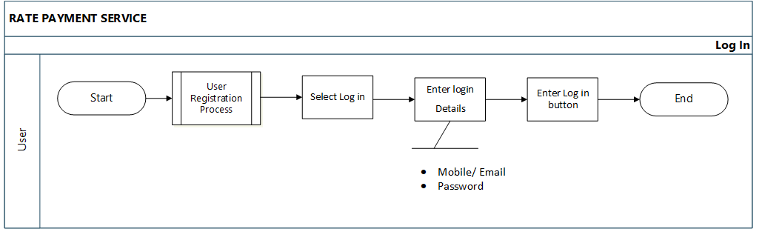

#### Figure 1-Login

### **Description**

**Scenario:** User login into the system.

**Actor:** Registered User

**Precondition:** The user should have an internet connection.

The user should have a web browser

The user should have registered to the system.

* Registered users can access the Rate payment service, after they log in to the system. Users must enter their Mobile Number / Email and Password to log in to the system.

### **Stimulus/ Responses**

* **Stimulus:** The user clicks the login button.

**Response:** The system displays the login form.

* **Stimulus:** The user enters login details and clicks the log-in button.

**Response:** Use will be directs to the user overview.

* **Stimulus**: If the user enters an invalid Mobile number or Email.

**Response**: The system displays an error message.

* **Stimulus**: The user enters an Invalid password.

**Response**: The system displays an error message.

**Error flow**

* If the user enters an invalid mobile number or email, the system will display “Invalid Mobile Number” or “Invalid Email.”
* User enters an invalid email/mobile number or password to the system display “Invalid credential.”

### **Functional Requirement**

**REQ-1:** The system should be able to show the Login option.

**REQ-2:** The system should be able to display the Login form.

**REQ-3:** The user should be able to enter details for the Login form.

**REQ-4:** The user should be able to submit the Login form.

**REQ-5:** The system should be able to check the validity of login details.

**REQ-6:** The system should be able to load the user dashboard.

# **Add new property**

### **Flow chart**

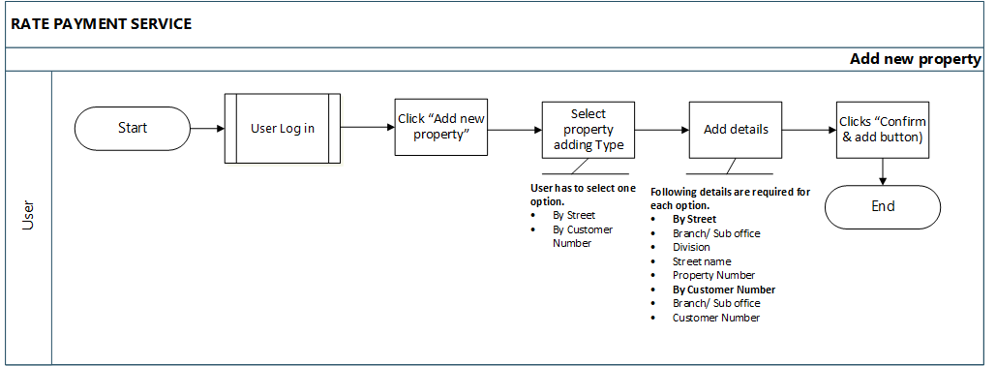

#### Figure 2- Add new property

### **Description**

**Scenario:** User adds a new property

**Actor:** User

**Precondition:** The user should have a web browser.

The user should have an internet connection.

The user should have registered to the system.

The user should have logged in to the system.

* After logging in to the system, users can add a new property selecting by street or customer number. Commonly both this option user has to select Branch or Sub office.
* **Add new property by street.**

The user has to select the following details.

|  |  |  |
| --- | --- | --- |
| **Attribute** | **Input Type** | **Comment** |
| Branch/ Sub office | Dropdown | Required |
| Division | Dropdown | Required |
| Street name | Dropdown | Required |
| Property Number | Dropdown | Required |

* **Add new property by customer number.**

The user must add the following details and search for the property details.

|  |  |  |
| --- | --- | --- |
| **Attribute** | **Input Type** | **Comment** |
| Branch / Sub office | Drop-down | Required |
| Custom No | Text field | Required |

* After adding the branch and customer number user has to click the “Search “Button.

### **Stimulus/ Responses**

* **Stimulus:** The user clicks the “Add new property” Button.

**Response:** System displays “Add new property” overview.

* **Stimulus:** If the user clicks the “By street “button and selects a branch using the drop- down menu.

**Response:** The system displays a drop-down menu for select divisions.

* **Stimulus:** User selects division.

**Response:** The system displays a drop-down menu to select the street name.

* **Stimulus:** User selects Street name.

**Response:**  The system displays the drop-down menu for selecting to property type.

* **Stimulus:** User selects Property type.

**Response:** The system displays user property details.

* **Stimulus:** Else User clicks the “By Customer No” Button.

**Response:** The system displays a drop-down menu for adding a Branch and a text field for

Adding to the customer Number.

* **Stimulus:** The user adds details and clicks the search button.

**Responses:** The system displays user property details.

* **Stimulus:** The user clicks the “Confirm& add” Button.

**Response:** System displays Confirmation Box (“Are you sure? I agree to add this property to my account!”).

* **Stimulus:** The user clicks the “Yes, do it” Button.

**Response:** The system adds property details to the “My Property “list.

* **Stimulus:** If the user clicks the “Cancel” Button.

**Response:**  System display added property details.

**Error Flow**

* If the user is not selected, the branch or Sub office system displays the error message “Branch ID cannot be null or empty.”
* If the user does not enter the customer number, the system displays the following message “Please enter customer Number.”
* After selecting all the required details system automatically displays the following details of the user property.
* Property Description
* Owner Name
* Annual Value

### **Functional Requirement**

**REQ-1:** The user should be able to add a new property by street.

**REQ-2:** The user should be able to add a new property by customer number.

**REQ-3:** The system should be able to display the user property details.

## **View added property details list.**

### **Flow chart**

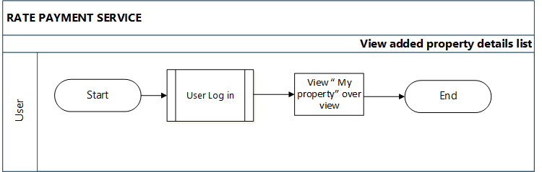

#### Figure 3- View added property details list

### **Description**

**Scenario:** User views the added details list of the user properties.

**Actor:** User

**Precondition:** The user should have a web browser

The user should have an internet connection.

The user should have registered to the system.

The user should have logged in to the system.

The user should have added the property details.

* After adding a new property, the details lists are viewed in the “my property “overview.
* The system displays the following information in each user property list.
* Customer Number
* Branch /Division/ Street/ Property Number
* Owner Name
* Description
* Annual Value
* The following options are included in the property overview.
* Add a new property ( 2 )
* View/payment
* Remove

### **Functional Requirement**

**REQ-1:** The system should be able to display the list of property details.

## **View details of a property.**

### **Flow chart**

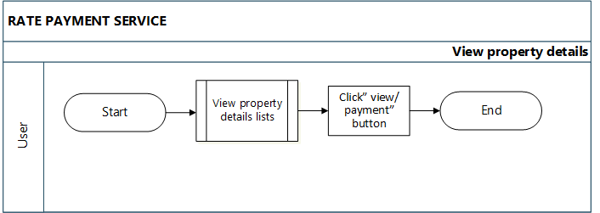

#### Figure 4- View details of property

### **Description**

**Scenario:** User views the user property details

**Actor:** User

**Precondition:** The user should have a web browser.

The user should have an internet connection.

The user should have registered to the system.

The user should have logged in to the system.

The user should have added the property details.

After the user adds the new property details system displays those details as lists of the property overview. Also, there is an option for the View or payment. Then the user selects the “View/ Payment” button, and the system displays the following details.

* Related office
* Division
* Street Name
* Property No
* Customer No
* Owner Name
* Description
* Annual Value/Quarter Rate
* Arrears
* Warrant
* Year Rate
* Future
* Discount

### **Stimulus/ Responses**

* **Stimulus:** The user clicks the “View/Payment” button.

**Response:** System displays “Details of Property” overview.

* **Stimulus:** User clicks “Go to Payment Button.”

**Response:** The system directs to the “Property Due amount “overview.

* **Stimulus:** The user clicks the “Back” button.

**Response:** The system goes to the previous page (“My property” lists overview).

### **Functional Requirement**

**REQ-1:** The user should be able to view the user property details.

**REQ-2**: The user should be able to go to payment.

**REQ-3:** The user should be able to go to the previous page.

## **View property due amount details and payment.**

### **Flow chart**

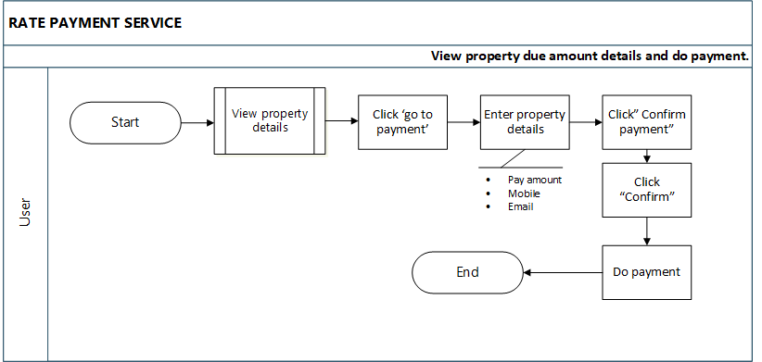

#### Figure 5-View property due amount and do Payment

### **Description**

**Scenario:** User views property due amount details.

**Actor:** User

**Precondition:** The user should have a web browser

The user should have an internet connection.

The user should have registered to the system.

The user should have logged in to the system.

The user should have added the property details.

* Users can check the property details and can view property due amount details. Also can make payments.
* The system displays the property due amount details.
* The system displays the following details.
* Arrears
* Warrant
* Year rate
* Future
* Discount
* Due for Today
* Rate
* Due for year
* Due for year
* Total Document for the year
* Division
* Street name
* Property Number
* The user should enter the following details for the payment.

|  |  |  |
| --- | --- | --- |
| **Attribute** | **Input Type** | **Comment** |
| Pay Amount | Text field | Required |
| Mobile | Text field | Not Required |
| Email | Text field | Not Required |

### **Stimulus/ Responses**

* **Stimulus:** The user clicks the “Go to payment” button.

**Response:** The system displays Property due amount details.

* **Stimulus:** The user enters payment details and clicks the “Confirm payment “Button.

**Response:** The system displays details of payment.

* **Stimulus:** The user clicks the “Confirm “Button.

**Response:** The system displays a Confirmation box (“Are you sure? Continue this process”).

* **Stimulus:** User clicks “Yes, confirm it.”

**Response:** The system directs to the payment overview.

* **Stimulus:** The user successfully enters payment details and clicks the “Next” button.

**Response:** The system sends a Message and Email to the user.

* **Stimulus:** The user clicks the “cancel” Button.

**Response:** The system stays on the same page.

* **Stimulus:** The user clicks the “Back” button.

**Response:** The system directs to the “Details of property “Overview.

* **Stimulus:** The user clicks the “Back” button.

**Response:**  The system goes to the previous page (“My property” lists overview).

**Error flow**

* If the payment amount is empty, the system displays the pop-up error message “Please enter the payment amount.”

### **Functional Requirements**

**REQ-1:** The user should be able to view the property due amount details.

**REQ-2:** The user should be able to pay the rate amount.

**REQ-3:** The user should be able to confirm payment.

**REQ-4:** The user should be able to go to the previous page.

## **Remove property details**

### **Flow chart**

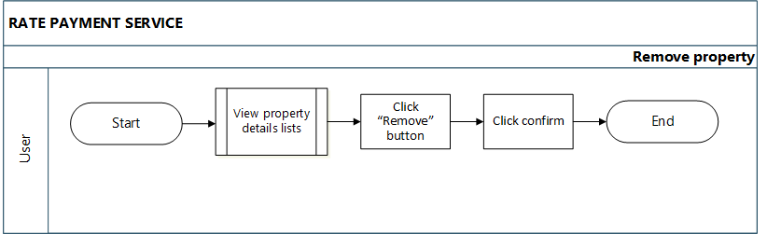

#### Figure 6- Remove Property

### **Description**

**Scenario:** User removing the added property details.

**Actor:** User

**Precondition:** The user should have a web browser

The user should have an internet connection.

The user should have registered to the system.

The user should have logged in to the system.

The user should have added the property details.

* Users can remove the added property details from the list.

### **Stimulus/ Responses**

* **Stimulus:** The user clicks the remove button.

**Response:** The system displays the Confirmation Box for removal.

* **Stimulus:** The user clicks the “Yes, delete it!” button.

**Response:** The system removes the selected details row from the list.

* **Stimulus:** If the user selects the “Cancel” button.

**Response:** System back into the property details list.

### **Functional requirement**

**REQ-1:** The user should be able to remove the selected details row from the list.

**REQ-2:** The user should be able to confirm the removal.

# **EXTERNAL INTERFACE REQUIREMENT**

## **User Interfaces**

* Front-end software: Visual code
* Back-end software: ASP.net API, MySQL

## **Hardware Interfaces**

* Windows (version 7 or above) Web browser (suggestions: Chrome)

## **Software Interfaces**

* Use windows as the operating system.
* Use SQL with a database tool.
* MySQL, PHP, and ASP.Net to implement the project.

# **NON-FUNCTIONAL REQUIREMENT**

## **Software Quality Attributes**

* **Usability**

User should able to manage login portal easily.

* **Security**
* **Performance**

Every page should load within 2 seconds.

Make session time out period after 30 minutes.

* **Scalability**

Login system should have the ability to perform in workload.

## **Performance Requirements**

The system must be interactive, and the delays involved must be less. So, in every action response of the system, there are no immediate delays. The application shall be fast when loading. Also, when connecting to the database server, the wait to make a successful connection should be less for effective real-time communication. The Rate payment service shall handle expected and non-expected errors in ways that prevent loss of information and an extended downtime period.

## **Safety Requirements**

The web application should be able to protect itself from any external danger or attacks.

## **Security Requirements**

There is a need for proper and encrypted login authentication for users’ information should be protected from hacking. Information transmission should be securely transmitted to the database without any information changes. The database may crash anytime due to viruses or operating system failure. Therefore, it is required to take the database backup so that the database is not lost.

Appendix A – Analysis models

### Use case diagram

